**Unit 1: Digital Documentation (Advanced)**

# Learning Outcome - Create and apply styles in digital document

## Assignment 1

**Objective:** Using various commands to create styles in OO Writer.

**Task:** Type a paragraph with at least 100 words and create below given styles as instructed:

1. Heading: Font name: Font name: Times New Roman, Size: 24 , Colour: Red. Give the style name: Dream Heading (Use create style from selection command to create style)
2. Paragraph: Apply Style Text Body from the Style Gallery
3. Quote: Font Name: Broadway, Size:16, Colour: Blue, Alignment: Center. Give the style name: DreamQuot

**Solution:**

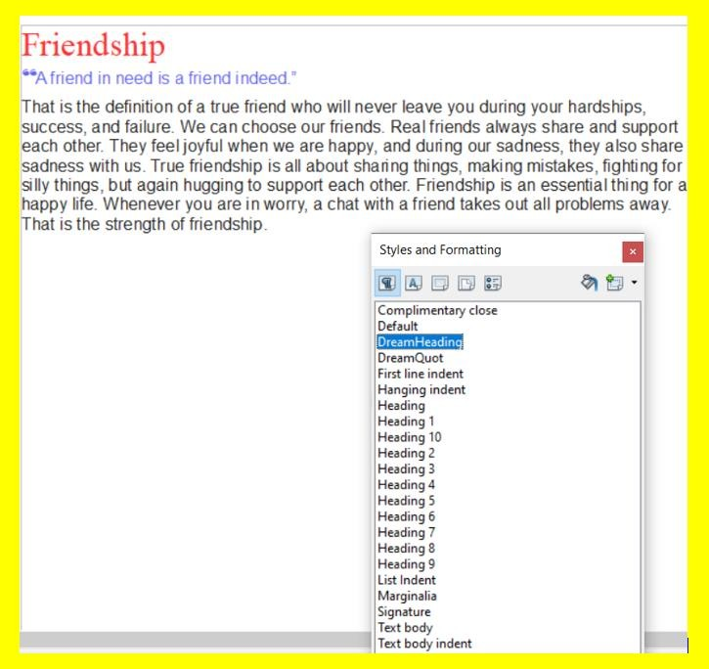

## Solution:

1. Creating styles for Heading and Quote
   * Open Styles and Formatting dialog box by clicking Format → Styles and Formatting
   * Click on New Style From Selection from the dialog box.
   * Type the desired names. For example Dream Heading for heading and DreamQuot for Quote
   * Now right click on the particular style to change the format.
   * Select the given formatting from the update style dialog box.
   * Click on OK
2. Applying styles from Gallery (Text Body to paragraph)
   * Select the paragraph
   * Open Styles and Formatting Dialog box
   * Select the Text Body style
   * Now select the fill format icon from the dialog box
   * Drag over the selected paragraph

# Learning Outcome – Insert and Use Images in digital document

## Assignment 2

**Objective:** Inserting images and shapes and rearranging them

**Task:**

1. Create a new document in OO Writer and Type a paragraph.
2. Insert a picture of your choice.
3. Adjust the picture at top left to the paragraph.
4. Insert some shapes and write additional text into the shapes.



**Solution:**

**Steps:**

1. Open OO Writer and Type the paragraph.
2. Click on Insert → Picture → From File.
3. Select the picture to insert.
4. Resize the picture according to the need.
5. Go to the picture properties and select Wrap → Parallel option.
6. Insert shape and insert the desired text.
7. Right Click on the shape and choose Wrap → Optimal Page Wrap option.

# Learning Outcome - Create and use template

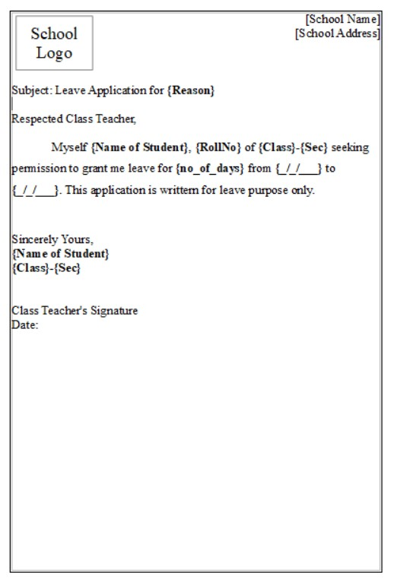

## Assignment 3

**Objective:** Creating templates in OO Writer and saving for distribution.

**Task:**

* Prepare a template for the application writing format.
* Apply formatting as required.
* Set this template as a default template.
* Change the default template to custom template. Change the formatting as you wish.

**Solution**

## Application Letter Template Contents

* 1. Insert the shape for school logo.
  2. Type School Name and Address as displayed in the screen shot.
  3. Type Subject line.
  4. Type the matter required for the application as displayed in above screen shot.
  5. Apply formatting as your wish.
  6. Click on Format → Page option. Page Style dialog box will open.
  7. Save the file.
  8. Now click on File → Templates → Save to mark your document as template.

## Set up a custom default template in OO writer

1. Click on File → Templates → Organize.
2. Choose the folder of template.
3. Select desired template to set as default template.

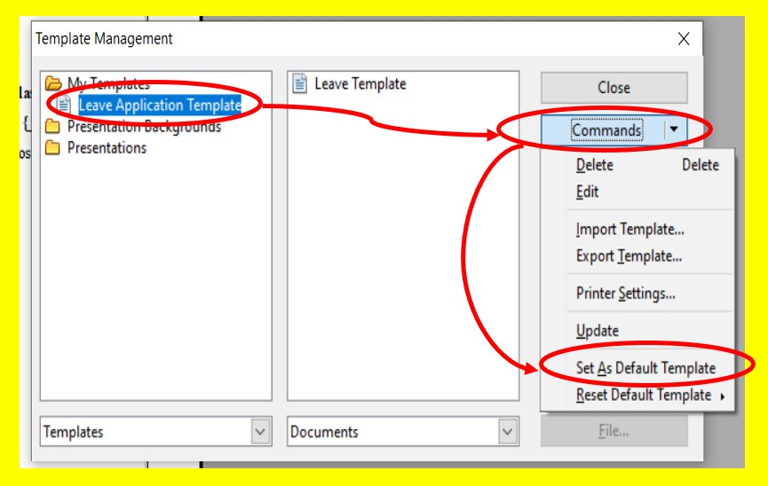

# Learning Outcome – Create and Customize Table of Contents

## Assignment 4

**Objective:** Create and Customize Table of Contents

**Task:** Prepare a document with different headings and apply a table of contents to it.

**Solution:**

1. Type the contents.
2. Apply appropriate level of headings from the Styles and Formatting window.
3. Click on Insert → Indexes and Tables → Indexes and Tables.
4. Select and apply the styles for the Table of Contents.
5. Click on OK.

# Learning Outcome – Implement the mail merge

## Assignment 5

**Objective:** Implement mail merge

**Task:** Write a letter to invite your parents and other guests to attend the annual day function of your school and merge them. Create a data source with at least 10 addresses.

1. Type a letter. Click on Tools – Mail Merge wizard. A mail merge dialog box appears.
2. 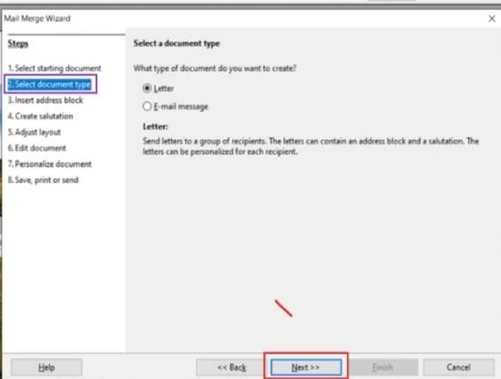Select Letter option. And click on Next.
3. For inserting address list just click on the select different address list option, select the address list you have prepared, click on Next.
4. Create salutation click on desire salutation click on the next tab.



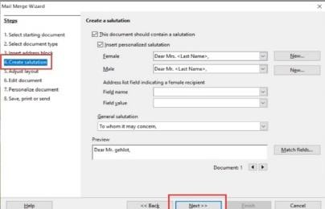

1. IF you want to adjust your content you adjust you increase the left and the top bar. Click on next button.

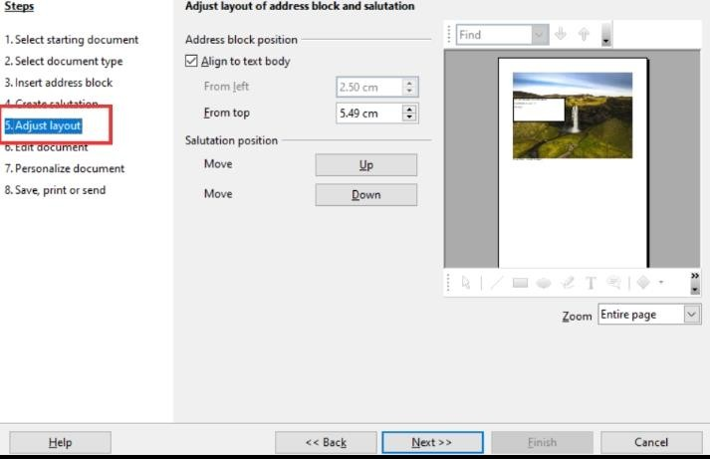

1. Edit document, Click the edit document option to edit you can apply to your document, if necessary. Click on next button.

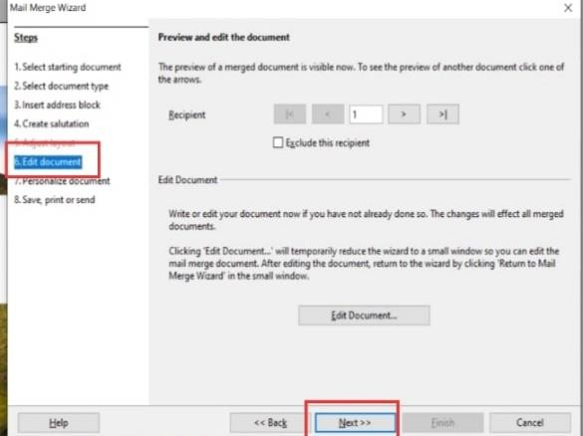

1. Click on Edit individual document. If you want to edit or click on Next button.

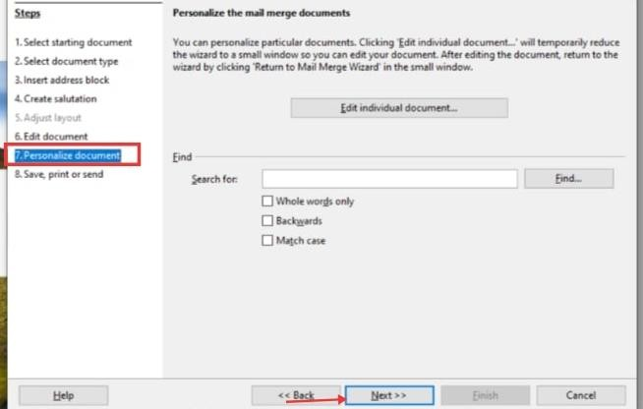

1. Click on Then, at last, you will get the final step to save, print or send the merged document.

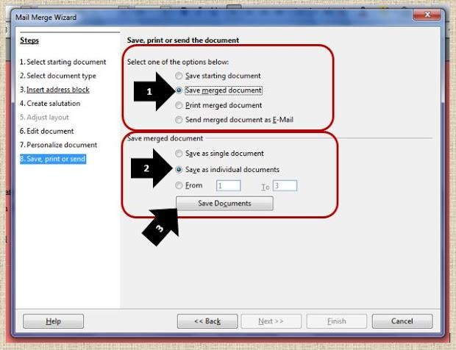

1. Click on save merged document. Then click on Save as individual documents.

**Unit 2: Electronic Spreadsheet (Advanced)**

**Learning Outcome Analyze data using scenarios and goal seek**

## Assignment 1

**Objective:** Applying Data Consolidation in OO Calc

**Task:**

1. Create a new file in spreadsheet software and enter data for 10 salesmen.
2. Add two worksheets in the file and modify the data for all 3 quarters.
3. Rename all worksheets like sheet1 - 2018, sheet2 - 2019 and sheet3 - 2020.
4. Now add one more worksheet at the end and rename as consolidated sheet.
5. Now type the serial no and names as displayed, use sum function to add data for 2018, 2019 and 2020 in respective cells using consolidation.

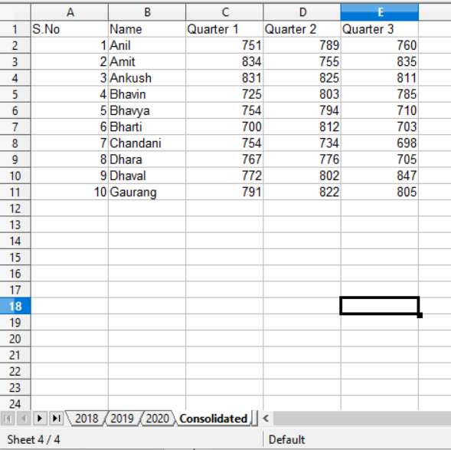

**Solution:**

1. Create a new spreadsheet in OO Calc.
2. Enter the data for Sheet 1 and rename sheet as 2018. To rename the worksheet right click on sheet tab then type the desired name. Press enter key to accept the name.

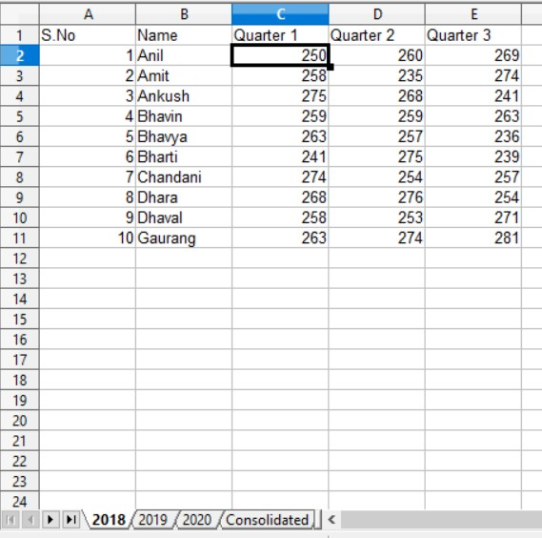

1. Follow the same instructions for next two worksheets.
2. Add one more worksheet to display the consolidation result and rename as Consolidated.
3. Select the cell ranges where results needs to appear.

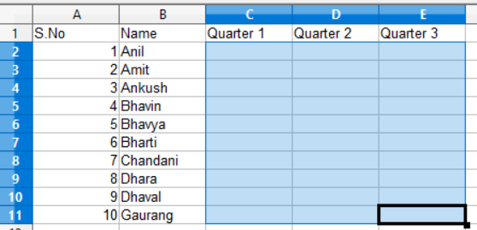

1. Click on Data ⇢ Consolidate option. A consolidate dialog box will appear.
2. Select your desired function (Sum here) and add references to the cells by selecting ranges.
3. Move the cursor on 2018 work sheet and select the range. Click on Add button.

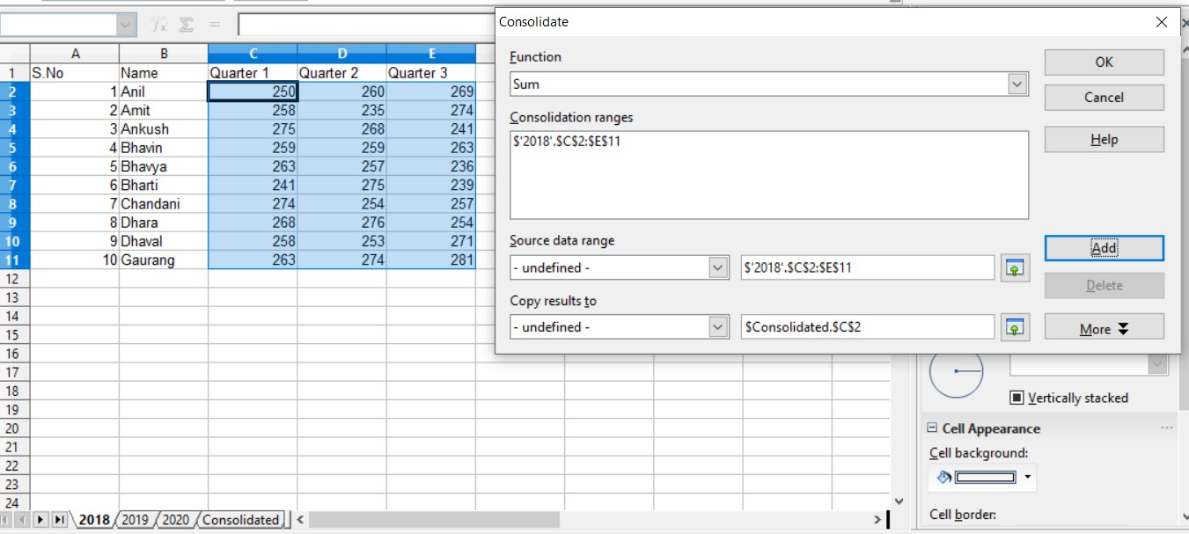

1. Repeat the same for 2019 and 2020 worksheet respectively.
2. Click on OK button.

## Assignment 2

**Objective:** Applying subtotal in OO Calc

**Task: Prepare a worksheet as following**

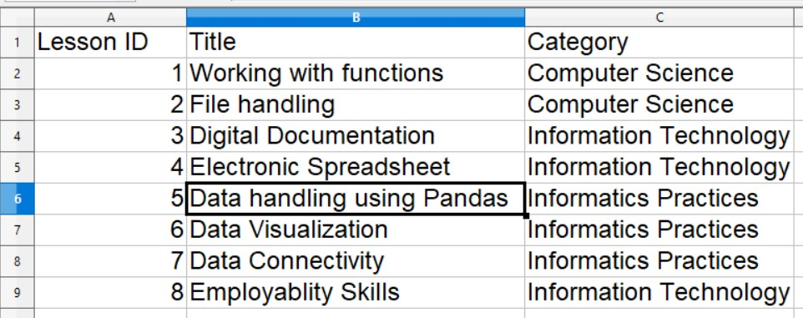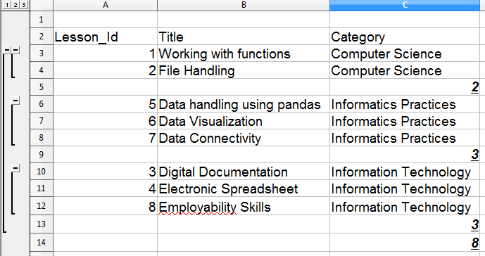

**Solution:**

1 Open spreadsheet software and enter the data as following:

1. Select the data. Needs to be grouped using subtotal.

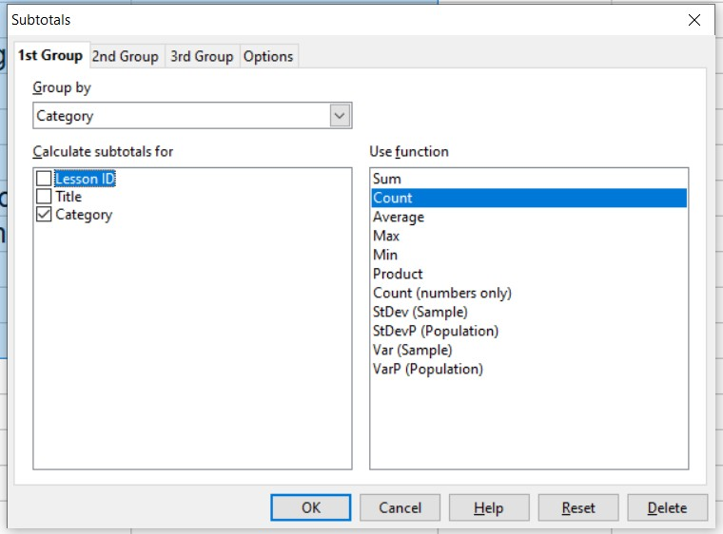

1. Click on Data → Subtotal. The Subtotal dialog box appears.
2. Select column in Group By option then mark the column to count the frequency for the

category and finally select the count function as displayed the following screenshot.

5. Click on OK button.

## Assignment 3

**Objective:** Link data and Spreadsheet

**Task: Prepare a worksheet as following**

1. Enter the data such as Roll no, GR NO, First Name, Last Name, Date of Birth, Father Name, Mother Name. Enter records for at least 10 students.
2. Rename this worksheet as "Student Profile".
3. Insert 3 new worksheets and rename as "**Periodic Test I**", "**Periodic Test II**" and "**Periodic Test III**" respectively.
4. In the **Periodic Test I** worksheet create a reference for Roll No, First Name, and Last Name columns from Student Profile by using the keyboard.
5. In the **Periodic Test II** worksheet create a reference for Roll No, First Name, and Last Name columns from Student Profile by using the mouse.
6. In the **Periodic Test III** worksheet create a reference for Roll No, First Name, and Last Name columns from Student Profile as you wish.

## Solution:

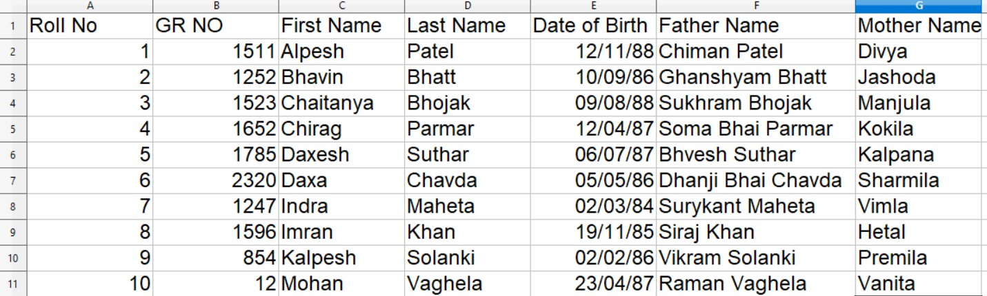

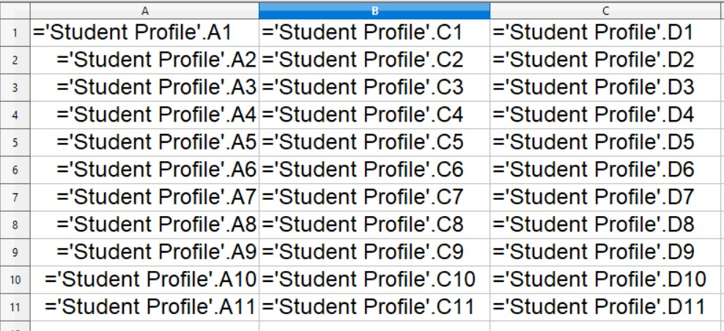

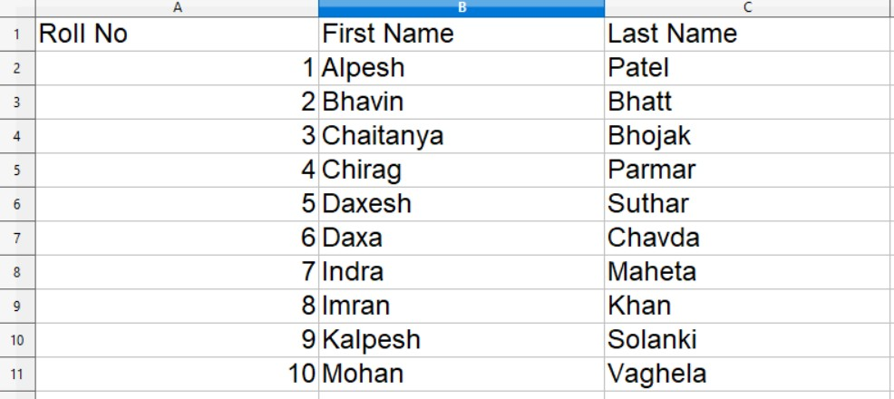

**Setting up worksheets**

* 1. Open spreadsheet software and type the required data as given in the question.
  2. Right click on Sheet tab, choose rename option. Now type “Student Profile”.
  3. Click on Insert Sheet option three times and rename them respectively.

## Creating Reference

1. Open Periodic Test I worksheet and place the cursor in the first cell.
2. Now type =.
3. Then move or select the student profile and select the cell where roll no is written.

## Repeat these steps for all worksheets, to link other cells.

**Learning Outcome – Share and review a spreadsheet**

## Assignment 4

**Objective:** Setting up a spreadsheet for sharing.

**Task:** Create a new file in spreadsheet software and enable sharing.

1. Create a new worksheet, enter data as you wish.
2. Save your worksheet with your desired name.
3. Enable sharing for your worksheet.

## Solution

1. Create a new worksheet and enter data.
2. Click on File → Save and Use proper name for the worksheet.
3. Click on Tools → Share Document.

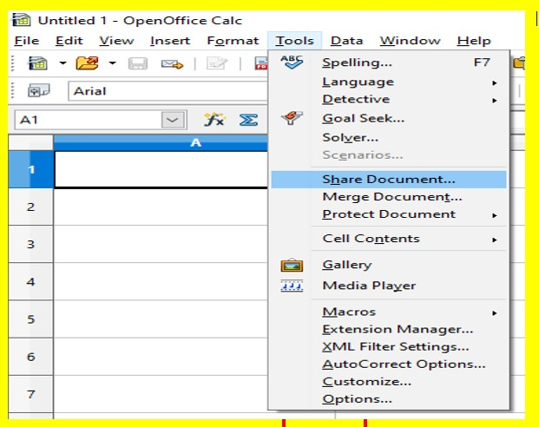

1. The Share Document dialog box will appear. Click on Share this spreadsheet with other users.

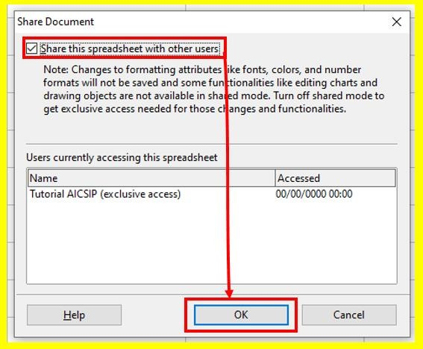

1. Click OK button.

## Assignment 5

**Objective:** Goal seek Application

**Task:** A student is planning her goals about the marks she should attain in the forthcoming examinations in order to achieve a distinction (75%). Assuming that the examination of each subject is for 100 marks, her marks of PT 1 and Term 1 are given as under.

|  |  |  |  |  |  |
| --- | --- | --- | --- | --- | --- |
|  |  | **English** | **Maths** | **Science** |  |
|  | **PT 1** | 72 | 63 | 54 |
|  | **Term 1** | 70 | 69 | 80 |
| Find out how many marks should she obtain in term 2 to secure distinction. | | | | | |

**Solution:**

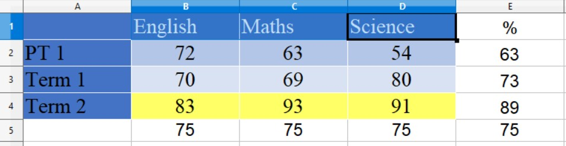

1. Enter data as given in the question itself.
2. Place the cursor to get the result for the marks of term 2.
3. Place the cursor in B5 and write avergae() formula.
4. Now click on Tools → Goal Seek option.
5. Check the formula cell (it should be B5 only).
6. Now write the target value i.e. 75.
7. Select the cell B4 to see the value to adjust the marks.
8. Repeat the same steps Maths and Science as well.

**Unit 3**

**Database Management System**

## Learning Outcome – Create and edit tables using wizard

**Assignment 1**

**Objective:** Steps to create a table using table wizard

**Task:** Create a table using wizard

## Create any table in OO base using table wizard.

**Solution**

* 1. Click on Start → All Programs → Open Office 4.1.7 → Open Office Base.
  2. OO Base window will open with Database Wizard. Select or create the database to work upon it. I have selected existing database db1. Click on Finish button.

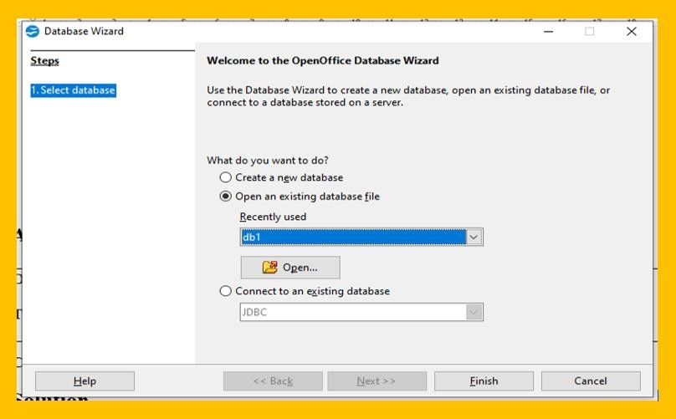

* 1. Now click on **Tables** button from Left pane and choose **Use Wizard to Create Table…**

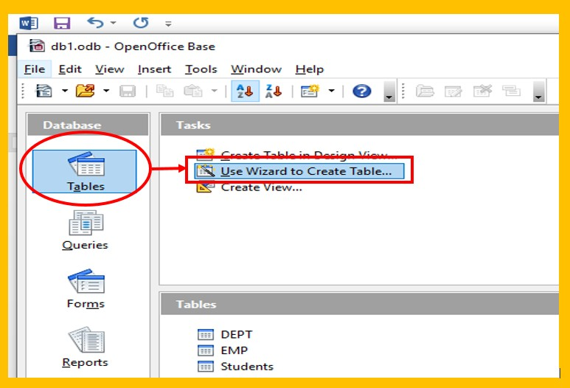option from the tasks window.

* 1. The Table Wizard will open. Follow wizard steps to create a table.

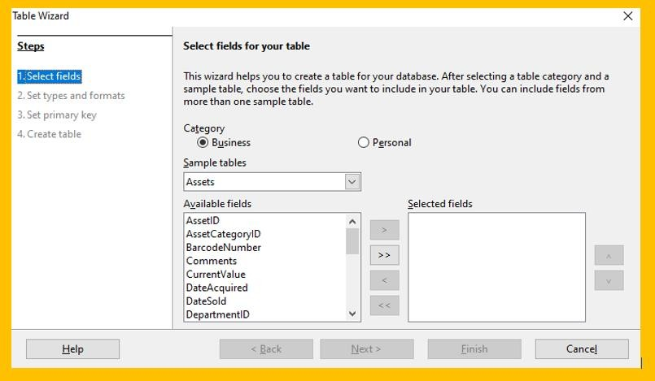

* 1. 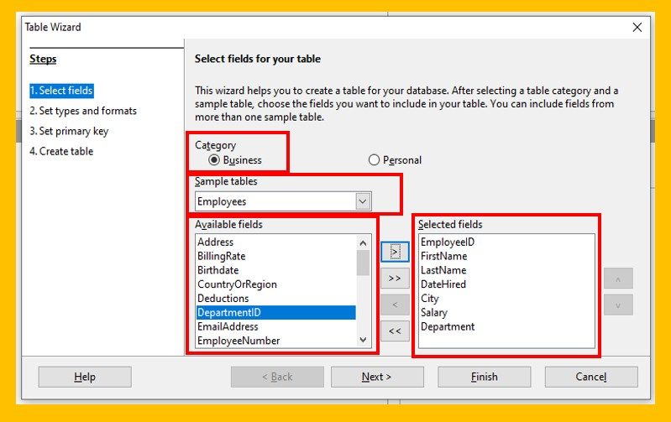In first step of wizard select the Category either Business or Personal, Table from list of sample tables, and fields from available fields. Click on Finish button.



* 1. 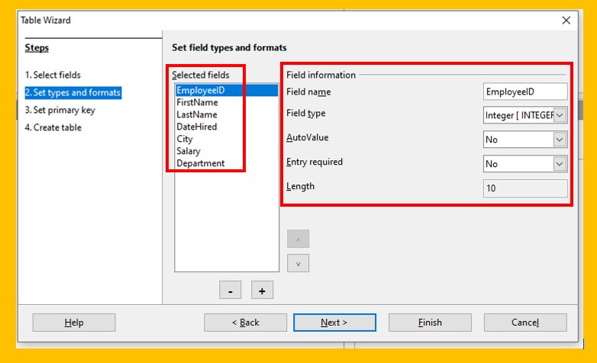Click on Next and select field types and all if you want to change it. Click on Next.
  2. Set a primary key for your table in this step. I have selected EmplyeeID as Primary key.

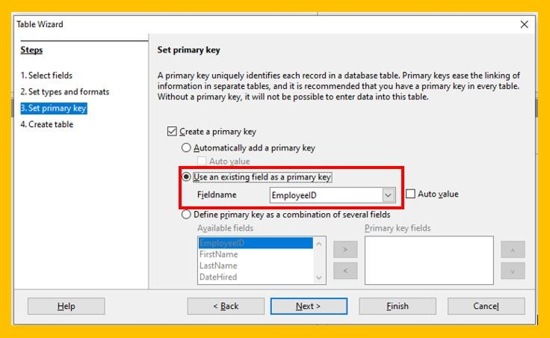

* 1. If you wish to change the table name then type new name for the table and click on Insert Data immediately, and click on Finish.

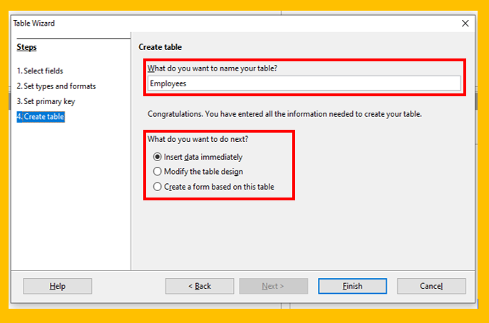

* 1. Insert data.

## Learning Outcome – Retrieve data using query

**Assignment 2**

**Objective:** Query creation using wizard

**Task:** Create table Marksheet (Using SQL Command )and perform the bellow given queries using wizard and design view.

|  |  |  |
| --- | --- | --- |
| **Field Name** | **Data Type** | **Size** |
| Stud_No | Integer | 2 |
| Name | Text | 15 |
| RollNo | Integer | 3 |
| Sub101 | Decimal | 3,2 |
| Sub102 | Decimal | 3,2 |
| Sub103 | Decimal | 3,2 |

1. In the Database file Add these Fields: (Total: Datatype- Number 3 digits, Percentage: Datatype - Number 3 digits with 2 decimal places, Grade: Datatype- Char with 2 letters)
2. Insert more 3 records in MARKSHEET using SQL mode.
3. Display name, rollno, marks of 3 subjects, total and percentage using design view.
4. Display name, rollno, grades from the marksheet table using query wizard.
5. Display the maximum marks for Sub101 and minimum marks for Sub102 using design view.
6. Display the rollno, name and percentage whose percentage are more than 70 using design view.
7. Display all the record in ascending order of names using design view.

## Solution

**Create table command**

create table “marksheet” (“Stud_no” tinyint primary key, “Name” varchar(15), “RollNo” tinyint, “Sub101” decimal(5,2), “Sub102” decimal(5,2), “Sub103” decimal(5,2))

## Output

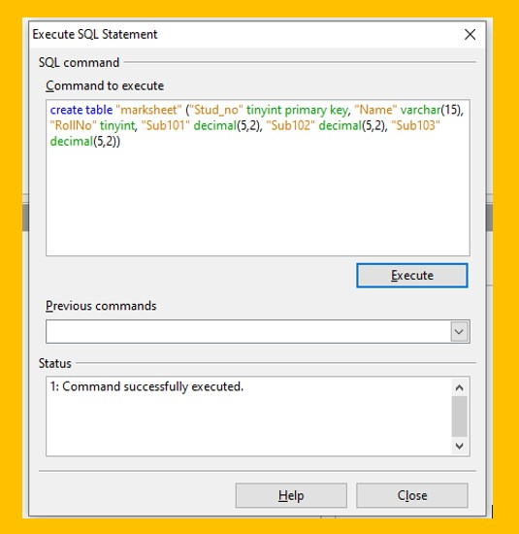

**Queries**

1. Add Columns
   1. Add column Total → alter table "marksheet" add column "Total" tinyint
   2. Add column Percentage → alter table "marksheet" add column "Percentage" decimal(5,2)
   3. Add column grade → alter table "marksheet" add column "Grade" char(2)

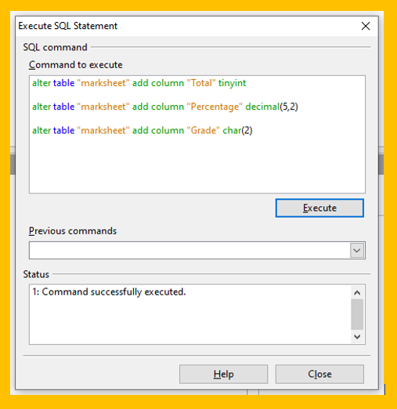

1. Insert records

1. insert into "marksheet" values (101, 'Sagar', 105, 27, 25, 28, 80 , 88 , 'B1')

1. Steps to perform a query using design view
   1. Click Queries → Create Query in Design View….
   2. The query design window will open.
   3. Select the marksheet table and click on Add button.
   4. Now select fields given in the question like name, rollno, marks,Sub101, Sub102, Sub103, Total and Percentage.
   5. Save the query.

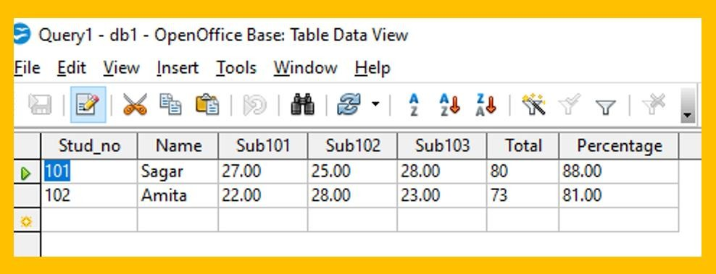

1. Query Wizard Steps
   1. Click on Queries → Use Wizard to Create Query…
   2. Query Wizard opens.
   3. Select the table marksheet and Select the fields given the question.

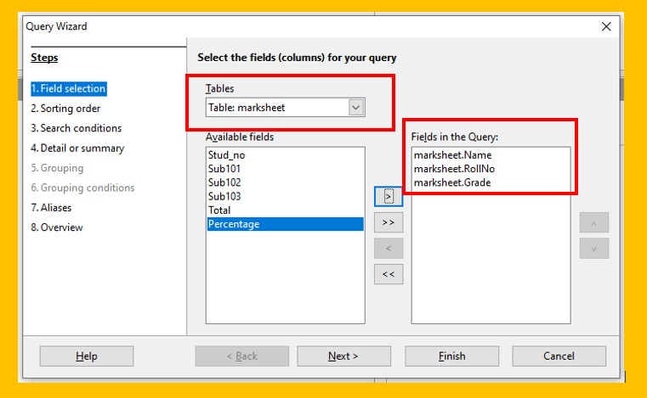

* 1. Click on finish.

## Output

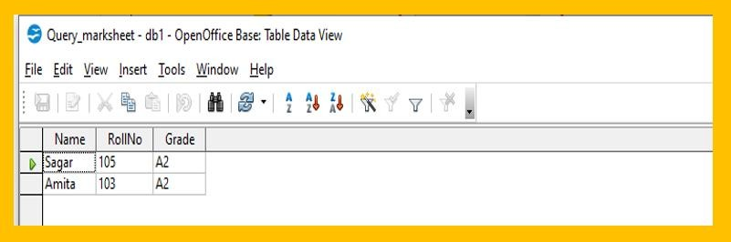

* 1. Display maximum marks and minimum marks for the fields given in the question, using design view.
     1. Click Queries → Create Query in Design View….
     2. The query design window will open.
     3. Select the marksheet table and click on Add button.
     4. Now select the field Sub101 and Sub102.
     5. Choose the function maximum under Sub101 and Minimum under Sub102.

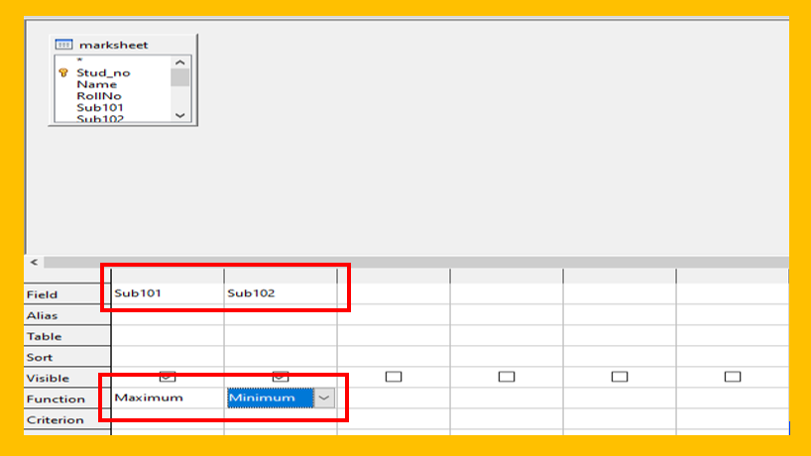

* + 1. Save the query and check the result.

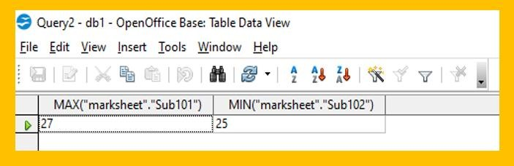

* 1. Display the rollno, name and percentage whose percentage are more than 70 using design view
     1. Click Queries → Create Query in Design View….
     2. The query design window will open.
     3. Select the marksheet table and click on Add button.
     4. Select columns given in the question i.e. Rollno, Name and Percentage.
     5. Type >70 in the front of criteria under the percentage field.

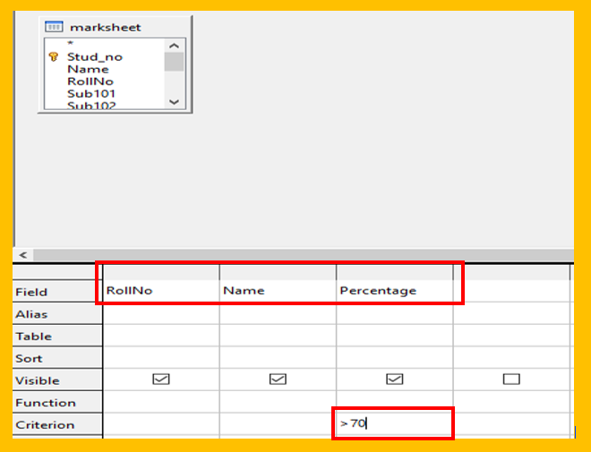

* + 1. Save the query and check the result.

## Output

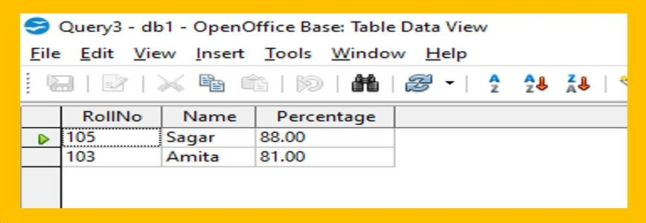

* + 1. Display all the record in ascending order of names using design view.
       1. Click Queries → Create Query in Design View….
       2. The query design window will open.
       3. Select the marksheet table and click on Add button.
       4. Select markesheet.* and name in the column list.
       5. Select sort → ascending under name field.
       6. Now click on Visible checkbox to hide the name column in result.

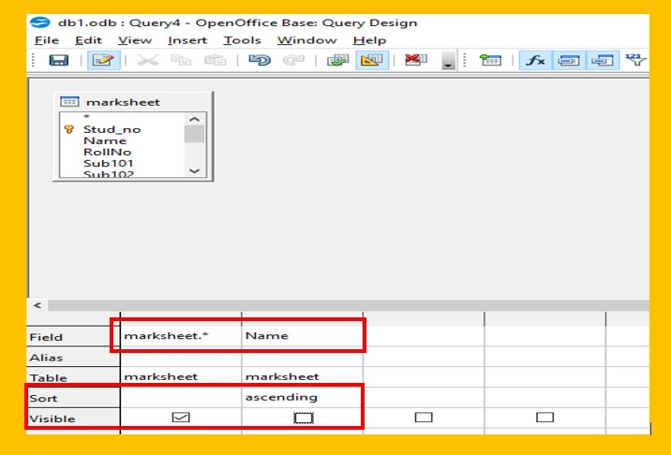

* + - 1. Save the query and check the result.

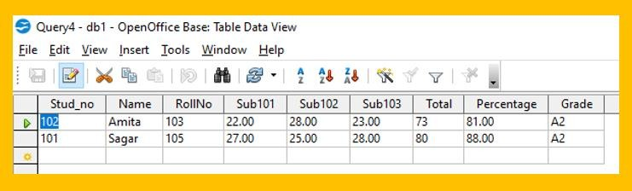

**Output**

## Learning Outcome – Create Forms and Reports using wizard Assignment 3

**Objective:** Creating form using wizard

**Task:** Create table a form using wizard by selecting all the fields for the table - Marksheet

**Solution**

Steps to create a form using wizard

1. Click on Forms → Use Wizard to Create Form…
2. A Form Wizard appears.

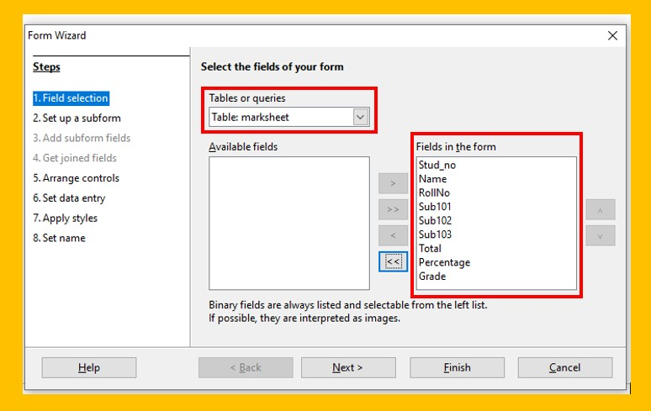

1. Select the table from Tables or Queries then add all the fields.
2. Click on Next button. Ignore step 3 and step 4.
3. Select the first option i.e. Columnar – Labels Left then click on the next button.

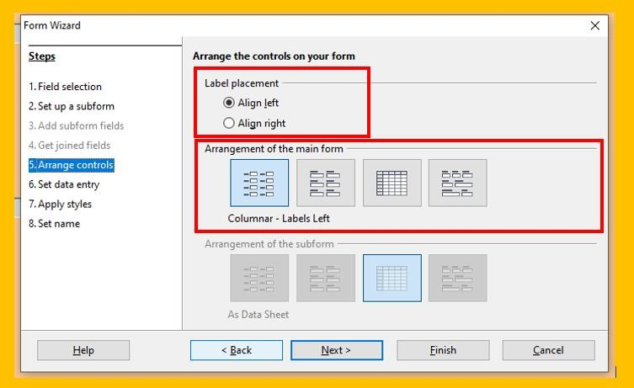

1. Now set data entry step will be there. Ignore this step and click on Next. Choose

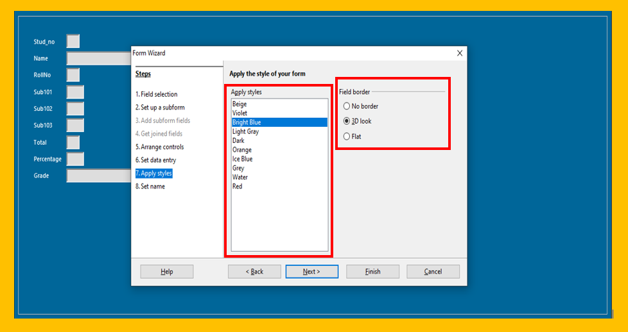

the styles for the form interface and click on next.

1. Type new name for the form and click on work with the form. Click on Finish

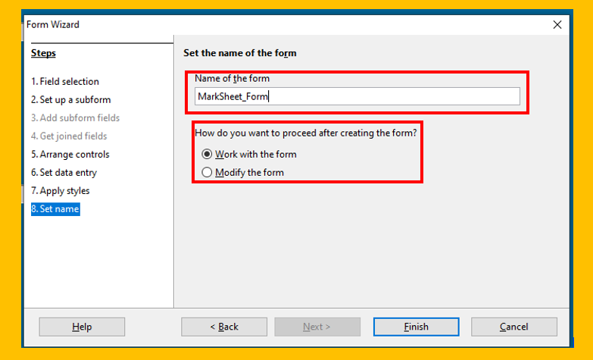

## Assignment 4

**Objective:** Creating report using wizard

**Task:** Create table a report using wizard by selecting all the fields for the table - Marksheet

**Solution**

1. Click on Reports → Use Wizard to Create report. The report wizard will open in the new window.
2. 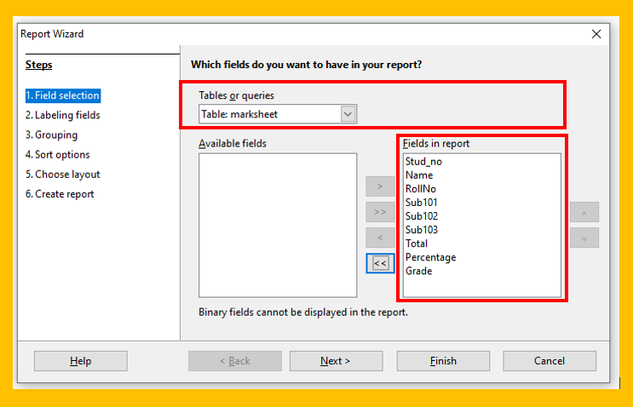Select the table and add fields.
3. Now change the label text that you want in the report. I have changed the label Stud_no into Adm. No. Click on Next.

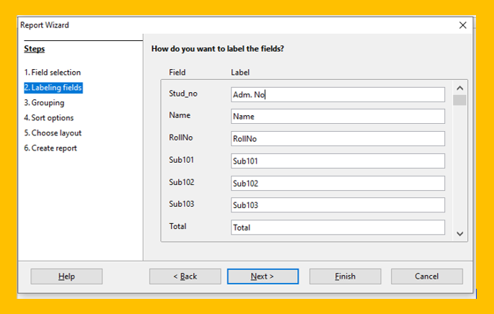

1. I have skipped groping and sorting options by click on Next button.
2. Now choose the layout. I have selected Outline-Elegant as Layout of Data, Landscape Orientation, and Bubbles Layout of Headers and Footers. Click on Next.

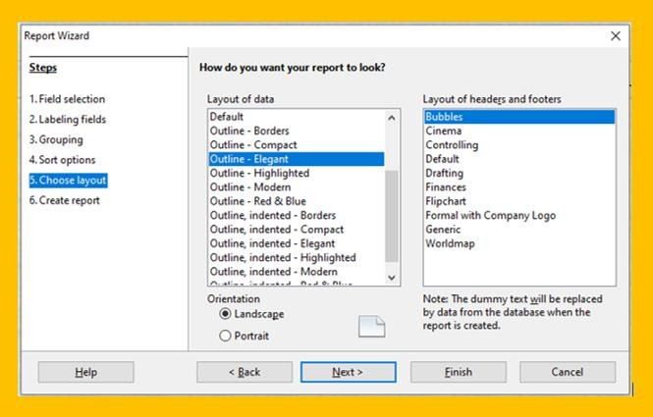

1. 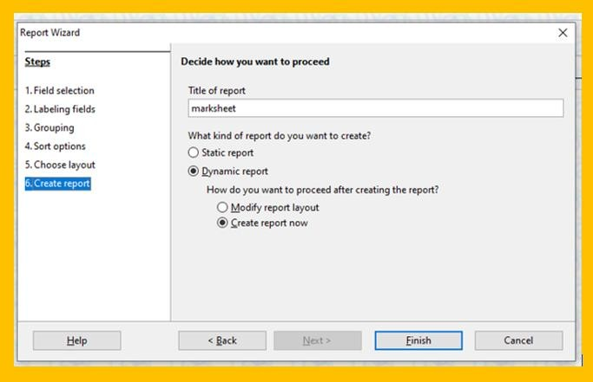Now type the title of the report and select dynamic report → Create report now option.
2. Now click on finish.

## Output

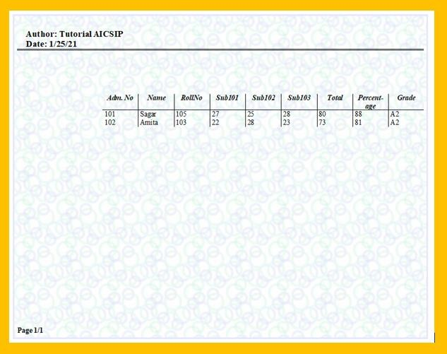

## Assignment 5

## 

## 

**Que. Write the command for the following table Student.**

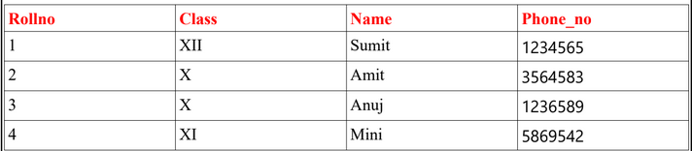

**1. Display all the records of table Student.**

**2. Insert record of your choice**

**3. Display record of student whose roll number is 3**

**4. Display record of students who are in class 'X**

**5. Display the record of 'Anuj'**

**Ans.**

1. Select * from student;

2. Insert into student values(5, 'XI' , 'Suman' , 6953245)

3. Select * from student where Rollno = 3;

4. Select * from student where class = 'X'

5. Select * from student where name = 'Anuj';

**Que. Illustrate the use of various options under computer Accessibility in Keyboard, Mouse, Display tab .**

**Ans.** To launch accessibility options in WindowsXP, Click Start > Control Panel >Accessibility Options.

The Accessibility Options window appears

**Keyboard Tab :**

**Sticky Keys**

Sticky Keys is an accessibility feature to help computer users with physical disabilities.

To enable Sticky Keys, select Use Sticky Keys.

• Click Apply.

• Click OK.

The Sticky Keys icon appears in the system tray.

**Filter Keys :**

Filter Keys is a feature of Microsoft Windows. It is an accessibility function that tells the keyboard to ignore brief or repeated keystrokes, making typing easier for people with hand tremors.

• To enable Filter Keys, check Use Filter Keys.

• Click Settings under Filter Keys and check “Ignore Repeated Keystrokes”.

• Click Apply.

• Click OK.

**Display Tab:**

Select the Display Tab. A window with options to configure accessibility options for display is displayed with option.

• High Contrast

• Cursor Options

**Mouse Tab :**

**MouseKeys**

MouseKeys is an accessibility feature that assists people who have difficulty using a mouse. Select the Mouse Tab, a window to configure accessibility options for mouse will be displayed

• To enable MouseKeys, Check Use MouseKeys.

• Click Apply.

• Click OK.

**Dear Students,**

**Please find Practical Assignments for preparation of Information Technology (402).**

**note down these practicals inside your IT practical file for IT practical exam 2022-23**